NAME: ALVEENA NAZ
REG NO. FA25-BSE-010
OOP LAB TASK 9

Activity 1:
public class JavaApplication49 {
public static void main(String[] args) {
Employee e = new Employee("ali","26/5/2026",50000);
Student s = new Student("sumaiya",21,3.74);
e.register();
s.register();
}

}
public interface RegisterForExams {
public void register();
}

public class Employee implements RegisterForExams{
private String name;
private String date;
private double salary;
Employee(){}
Employee(String n, String d , double s){
this.name=n;
this.date=d;
this.salary=s;
}
@Override
public void register()
{
System.out.println("Emplyee is register" + " Name: " + name + " Salary: " + salary + " Date: " + date);
}
}

public class Student implements RegisterForExams {
private String name;
private int age;
private double cgpa;
Student(){}
Student(String n, int a,double c){
this.name = n;
this.age = a;
this.cgpa = c;

}
@Override
public void register(){
System.out.println("Student is registered" + " Name: " + name + " CGPA: " + cgpa);
}
}

OUTPUT:
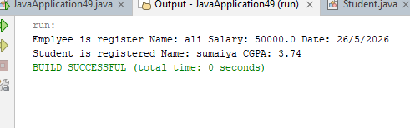

Activity 2:
public class JavaApplication50 {
public static void main(String[] args) {
I1 i1 = new B1();
i1.methodI1();
I2 i2 = (I2) i1;
i2.methodI2();
i2.methodI1();

i2 = new B1();
i2.methodI2();
i2.methodI1();

String var2 = ((A1) i1).methodA1();
System.out.println( " Var2" + var2);
String var3 = ((B1) i1).methodA1();
System.out.println( "var3: "+var3);

String var4 = i1.toString();
System.out.println("Var4: " + var4);
String var5 = i2.toString();
System.out.println("Var5: " + var5);

Object o1 = new B1();
B1 b1 = (B1) o1;
b1.methodI1();

}

}
public interface I1 {
public void methodI1();
}
public interface I2 extends I1{
public void methodI2();
}

public class A1 {
public String methodA1(){
return "I am in methodA1 of class A1.";
}
@Override
public String toString(){
return "return tostring() method of class A1.";
}
}

public class B1 extends A1 implements I2{
@Override
public void methodI1(){
System.out.println("I am in methodI1 of class B1");
}
@Override
public void methodI2(){
System.out.println("I am in methodI2 of class B1");
}
}

public class C1 implements I2{
@Override
public void methodI1(){
System.out.println("I am in methodI1 of class C1");
}
@Override
public void methodI2(){
System.out.println("I am in methodI2 of class C1");
}
}
public abstract class D1 implements I2{
@Override
public void methodI1(){
System.out.println("I am in methodI1 of class D1");
}
}
OUTPUT:
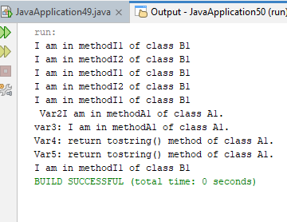

Graded Task 1:
public class JavaApplication51 {
public static void main(String[] args) {
Circle c = new Circle(4);
Rectangle r = new Rectangle(4.5,6.2);
System.out.println("Area of Circle " + c.getArea());
System.out.println("Area of Rectangle " + r.getArea());
}

}

public interface Shape {
public double getArea();
}

public class Rectangle implements Shape{
double length;
double width;
Rectangle(){}
Rectangle(double l,double w){
this.length =l;
this.width=w;
}
@Override
public double getArea(){
return length * width;
}
}

public class Circle implements Shape{
double radius;
Circle(){}
Circle(double r){
this.radius=r;
}

@Override
public double getArea(){
return (Math.PI * radius * radius);
}
}

OUTPUT:
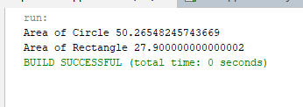

Graded Task 2:
public class JavaApplication52 {

public static void main(String[] args) {
Invoice in = new Invoice("as456","qwed",4,100);
Employee e = new SalariedEmployee("Eman","ABC123",60000);
System.out.println("Invoice: "+ in.getPaymentAmount());
System.out.println("Salary: " + e.getPaymentAmount());
}

}

public interface Payable {
public double getPaymentAmount();
}

public class Invoice implements Payable{
private String partNumber;
private String partDescription;
private int quantity;
private double pricePerItem;
Invoice(){}

Invoice(String pn, String pd, int q, double p){
this.partNumber = pn;
this.partDescription = pd;
this.quantity = q;
this.pricePerItem = p;
}

@Override
public double getPaymentAmount(){
return quantity * pricePerItem;
}
}

public abstract class Employee implements Payable{
private String name;
private String SSN;
Employee(){}
Employee(String n , String SSN){
this.name = n;
this.SSN = SSN;
}

}

public class SalariedEmployee extends Employee{
private double weeklySalary;
SalariedEmployee(){}
SalariedEmployee(String n , String SSN,double weeklySalary)
{
super(n,SSN);
this.weeklySalary = weeklySalary;
}
@Override
public double getPaymentAmount(){
return weeklySalary;
}
}

OUTPUT:
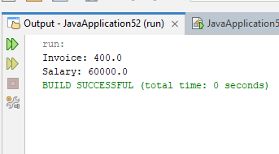

Graded Task 3:
public class JavaApplication53 {
public static void main(String[] args) {
InventoryItem item1 = new InventoryItem("Lays",012);
InventoryItem item2 = new InventoryItem("Kurkure",014);
if(item1.compareObject(item2)){
System.out.println("Id of "+ item1.getName() + "is greater");
}
else{
System.out.println("Id of "+ item2.getName() + " is greater");
}
}

}

public class InventoryItem implements Compare{
private String name;
private int id;
InventoryItem(){}

InventoryItem(String n , int id){
this.name =n;
this.id = id;
}
public void setName(String n){
this.name =n;
}
public void setId(int id){
this.id = id;
}

public String getName(){
return name;
}

public int getId(){
return id;
}

@Override
public boolean compareObject(Object o){
InventoryItem item = (InventoryItem) o;
if(this.id > item.id)
{
return true;
}
else
{
return false;

}
}
}

public interface Compare {
public boolean compareObject(Object o);
}
OUTPUT:
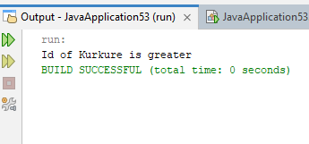

Graded Task 4:
public class JavaApplication54 {
public static void main(String[] args) {
String names[] = {"Ali","Hamza","Eman","Rabia","Sara"};
NameCollection c1 = new NameCollection(names);

for(int i=0;i<names.length;i++){
if(c1.hasNext(i)){
System.out.println("Name is "+ c1.getNext(i));
}
else{
System.out.println("No name found.");
}
}
}

}

public interface Enumeration {
public boolean hasNext(int index);
public Object getNext(int index);
}

public class NameCollection implements Enumeration{
String name[];
NameCollection(){}
NameCollection(String name[]){
this.name = name;
}
@Override
public boolean hasNext(int index){
if(!name[index].isEmpty())
return true;
else
return false;
}

@Override
public Object getNext(int index){
return name[index];

}
}

OUTPUT:
